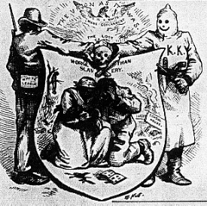 (1)
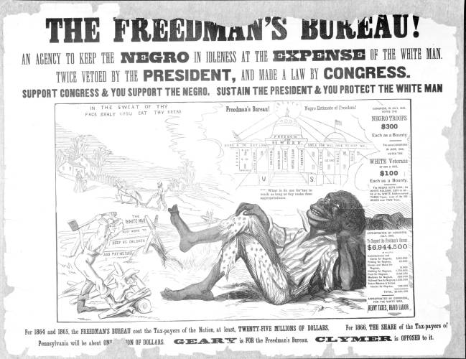 (2)

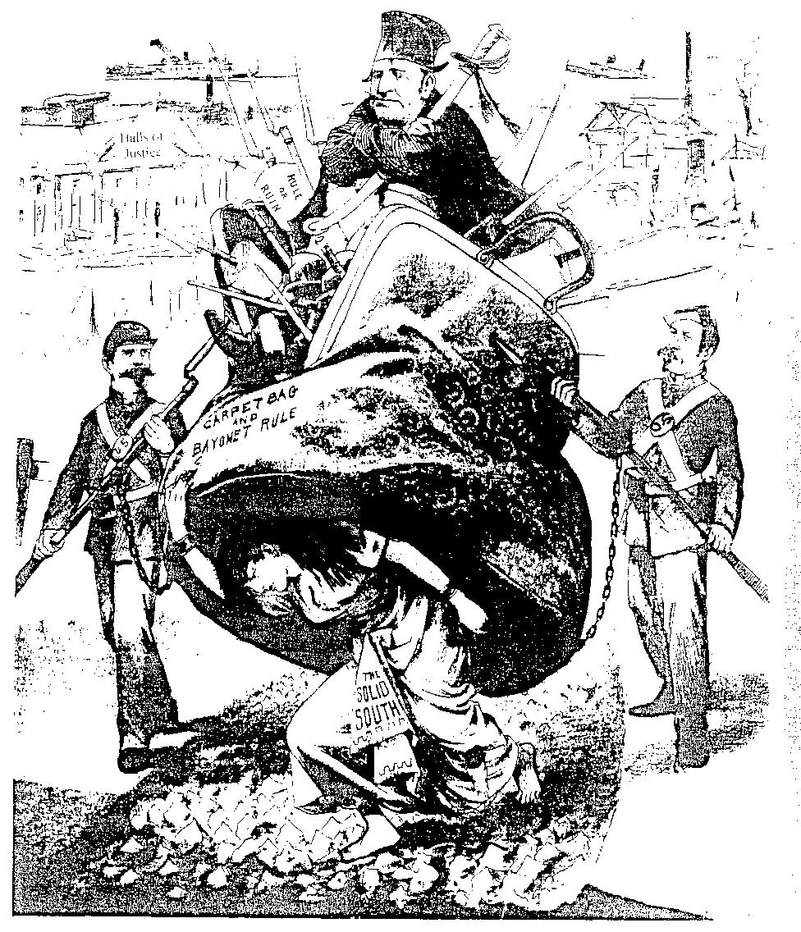 (3)
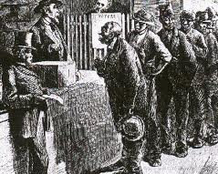 (4)
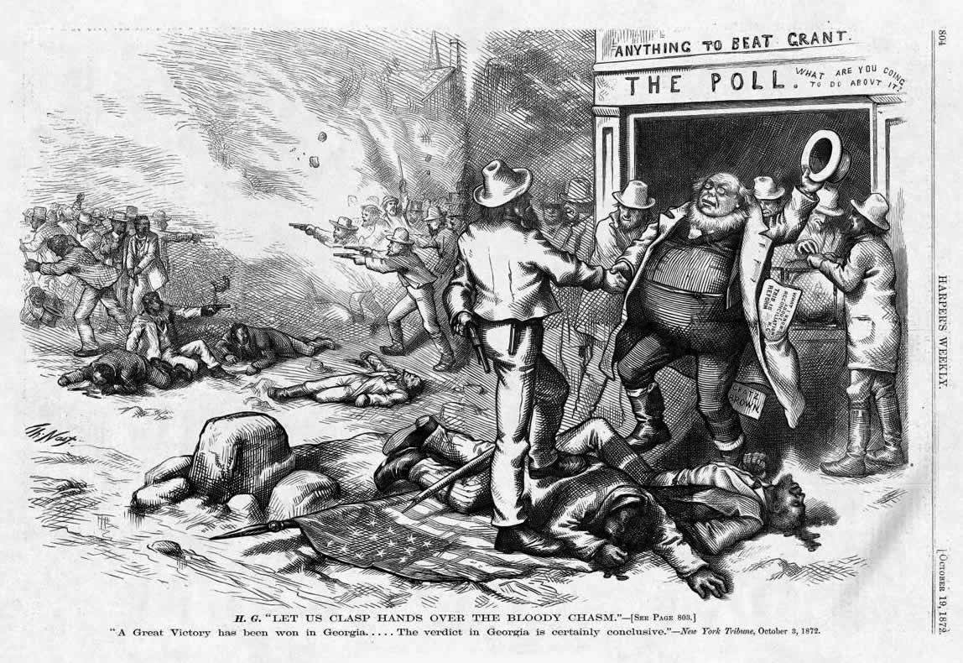 (5)

Mississippi Black Code (6)
The status of the Negro was the focal problem of Reconstruction. Slavery had been abolished by the Thirteenth Amendment, but the white people of the South were determined to keep the Negro in his place, socially, politically, and economically. This was done by means of the notorious "Black Codes," passed by several of the state legislatures. Northerners regarded these codes as a revival of slavery in disguise. The first such body of statutes, and probably the harshest, was passed in Mississippi in November 1865. Four of the statutes that made up the code are reprinted below.
Apprentice Law
Section 1. Be it enacted by the legislature of the state of Mississippi, that it shall be the duty of all sheriffs, justices of the peace, and other civil officers of the several counties in this state to report to the Probate courts of their respective counties semiannually, at the January and July terms of said courts, all freedmen, free Negroes, and mulattoes under the age of eighteen within their respective counties, beats, or districts who are orphans, or whose parent or parents have not the means, or who refuse to provide for and support said minors; and thereupon it shall be the duty of said Probate Court to order the clerk of said court to apprentice said minors to some competent and suitable person, on such terms as the court may direct, having a particular care to the interest of said minors:
Provided, that the former owner of said minors shall have the preference when, in the opinion of the court, he or she shall be a Suitable person for that purpose.
Section 2. Be it further enacted, that the said court shall be fully satisfied that the person or persons to whom said minor shall be apprenticed shall be a suitable person to have the charge and care of said minor and fully to protect the interest of said minor. The said court shall require the said master or mistress to execute bond and security, payable to the state of Mississippi, conditioned that he or she shall furnish said minor with sufficient food and clothing; to treat said minor humanely; furnish medical attention in case of sickness; teach or cause to be taught him or her to read and write, if under fifteen years old; and will conform to any law that may be hereafter passed for the regulation of the duties and relation of master and apprentice:
Provided, that said apprentice shall be bound by indenture, in case of males until they are twenty-one years old, and in case of females until they are eighteen years old.
Section 3. Be it further enacted, that in the management and control of said apprentices, said master or mistress shall have power to inflict such moderate corporeal chastisement as a father or guardian is allowed to inflict on his or her child or ward at common law:
Provided, that in no case shall cruel or inhuman punishment be inflicted.
Section 4. Be it further enacted, that if any apprentice shall leave the employment of his or her master or mistress without his or her consent, said master or mistress may pursue and recapture said apprentice and bring him or her before any justice of the peace of the county, whose duty it shall be to remand said apprentice to the service of his or her master or mistress; and in the event of a refusal on the part of said apprentice so to return, then said justice shall commit said apprentice to the jail of said county, on failure to give bond, until the next term of the county court; and it shall be the duty of said court, at the first term thereafter, to investigate said case; and if the court shall be of opinion that said apprentice left the employment of his or her master or mistress without good cause, to order him or her to be punished, as provided for the punishment of hired freedmen, as may be from time to time provided for by law, for desertion, until he or she shall agree to return to his or her master or mistress:

Civil Rights of Freedmen (7)
Section 2. Be it further enacted, that all freedmen, free Negroes, and mulattoes may intermarry with each other, in the same manner and under the same regulations that are provided by law for white persons:
Provided, that the clerk of probate shall keep separate records of the same.

Section 3. Be it further enacted, that all freedmen, free Negroes, and mulattoes who do now and have heretofore lived and cohabited together as husband and wife shall be taken and held in law as legally married, and the issue shall be taken and held as legitimate for all purposes. That it shall not be lawful for any freedman, free Negro, or mulatto to intermarry with any white person; nor for any white person to intermarry with any freedman, free Negro, or mulatto; and any person who shall so intermarry shall be deemed guilty of felony and, on conviction thereof, shall be confined in the state penitentiary for life; and those shall be deemed freedmen, free Negroes, and mulattoes who are of pure Negro blood; and those descended from a Negro to the third generation inclusive, though one ancestor of each generation may have been a white person.

Penal Code
Section 1. Be it enacted by the legislature of the state of Mississippi, that no freedman, free Negro, or mulatto not in the military service of the United States government, and not licensed so to do by the board of police of his or her county, shall keep or carry firearms of any kind, or any ammunition, dirk, or Bowie knife; and, on conviction thereof in the county court, shall be punished by fine, not exceeding $10, and pay the costs of such proceedings, and all such arms or ammunition shall be forfeited to the informer; and it shall be the duty of every civil and military officer to arrest any freedman, free Negro, or mulatto found with any such arms or ammunition, and cause him or her to be committed for trial in default of bail.

Section 2. Be it further enacted, that any freedman, free Negro, or mulatto committing riots, routs, affrays, trespasses, malicious mischief, cruel treatment to animals, seditious speeches, insulting gestures, language, or acts, or assaults on any person, disturbance of the peace, exercising the function of a minister of the Gospel without a license from some regularly organized church, vending spirituous or intoxicating liquors, or committing any other misdemeanor t e punishment of which is not specifically provided for by law shall, upon conviction thereof in the county court, be fined not less than $10 and not more than $100, and may be imprisoned, at the discretion of the court, not exceeding thirty days.

Section 3. Be it further enacted, that if any white person shall sell, lend, or give to any freedman, free Negro, or mulatto any firearms, dirk, or Bowie knife, or ammunition, or any spirituous or intoxicating liquors, such person or persons so offending, upon conviction thereof in the county court of his or her county, shall be fined not exceeding $50, and may be imprisoned, at the discretion of the court, not exceeding thirty days:

Agreement between Landlord and Sharecropper (8)
This agreement, made and entered into this 18th day of January, 1879, between Solid South, of the first part, and John Dawson, of the second part.

Witnesseth: that said party of the first part for and in consideration of eighty-eight pounds of lint cotton to be paid to the said Solid South, as hereinafter expressed, hereby leases to said Dawson, for the year A. D. 1879, a certain tract of land, the boundaries of which are well understood by the parties hereto, and the area of which the said parties hereby agree to be fifteen acres, being a portion of the Waterford Plantation, in Madison Parish, Louisiana.

The said Dawson is to cultivate said land in a proper manner, under the general superintendence of the said Solid South, or his agent or manager, and is to surrender to said lessor peaceable possession of said leased premises at the expiration of this lease without notice to quit. All ditches, turn-rows, bridges, fences, etc. on said land shall be kept in proper condition by said Dawson, or at his expense. All cotton-seed raised on said land shall be held for the exclusive use of said plantation, and no goods of any kind shall be kept for sale on any said land unless by consent of said lessor.
If said Solid South shall furnish to said lessee money or necessary supplies, or stock, or material, or either or all of them during this lease, to enable him to make a crop, the amount of said advances, not to exceed $475 (of which $315 has been furnished in two mules, plows, etc.), the said Dawson agrees to pay for the supplies and advances so furnished, out of the first cotton picked and saved on said land from the crop of said year, and to deliver said cotton of the first picking to the said Solid South, in the gin on said plantation, to be by him bought or shipped at his option, the proceeds to be applied to payment of said supply bill, which is to be fully paid on or before the 1st day of January, 1880.

After payment of said supply bill, the said lessee is to pay to said lessor, in the gin of said plantation, the rent cotton herein before stipulated, said rent to be fully paid on or before the 1st day of January, 1880. All cotton raised on said land is to be ginned on the gin of said lessor, on said plantation, and said lessee is to pay $4 per bale for ginning same.

To secure payment of said rent and supply bill, the said Dawson grants unto said Solid South a special privilege and right of pledge on all the products raised on said land, and on all his stock, farming implements, and personal property, and hereby waives in favor of said Solid South the benefit of any and all homestead laws and exemption laws now in force, or which may be in force, in Louisiana, and agrees that all his property shall be seized and sold to pay said rent and supply bill in default of payment thereof as herein agreed. Any violation of this contract shall render the lease void.
[signed]

Solid South

John Dawson

X (his mark)

Excerpt from:
Civil Rights Act of 1866 (9)
14 Stat. 27-30, April 9, 1866 A.D.
CHAP. XXXI.
An Act to protect all Persons in the United States in their Civil Rights, and furnish the Means of their Vindication.
Be it enacted by the Senate and House of Representatives of the United States of America in Congress assembled, That all persons born in the United States and not subject to any foreign power, excluding Indians not taxed, are hereby declared to be citizens of the United States; and such citizens, of every race and color, without regard to any previous condition of slavery or involuntary servitude, except as a punishment for crime whereof the party shall have been duly convicted, shall have the same right, in every State and Territory in the United States, to make and enforce contracts, to sue, be parties, and give evidence, to inherit, purchase, lease, sell, hold, and convey real and personal property, and to full and equal benefit of all laws and proceedings for the security of person and property, as is enjoyed by white citizens, and shall be subject to like punishment, pains, and penalties, and to none other, any law, statute, ordinance, regulation, or custom, to the contrary notwithstanding.

Civil Rights Act of 1875 (10)
18 Stat. Part III, p. 335 (Act of Mar. 1, 1875).
Chap. 114. -- An act to protect all citizens in their civil and legal rights. Whereas, it is essential to just government we recognize the equality of all men before the law, and hold that it is the duty of government in its dealings with the people to mete out equal and exact justice to all, of whatever nativity, race, color, or persuasion, religious or political; and it being the appropriate object of legislation to enact great fundamental principles into law:
Therefore, Be it enacted by the Senate and House of Representatives of the United States of America in Congress assembled, That all persons within the jurisdiction of the United States shall be entitled to the full and equal and enjoyment of the accommodations, advantages, facilities, and privileges of inns, public conveyances on land or water, theaters, and other places of public amusement; subject only to the conditions and limitations established by law, and applicable alike to citizens of every race and color, regardless of any previous condition of servitude.

The First-Class Men of Our Town (11)
Abram Colby, a former slave and member of the Georgia legislature, was called to Washington in 1872 to testify before a joint House and Senate committee investigating reports of Southern violence.
Members of the Ku Klux Klan had beaten Colby savagely in 1869 in an attempt to end his political activities as a Radical Republican, after earlier efforts to bribe the black legislator had failed. Colby, permanently injured by the assault which had nearly killed him, defied intimidation to remain active in eastern Georgia politics.
Colby: On the 29th of October 1869, [the Klansmen] broke my door open, took me out of bed, took me to the woods and whipped me three hours or more and left me for dead. They said to me, "Do you think you will ever vote another damned Radical ticket?" I said, "If there was an election tomorrow, I would vote the Radical ticket." They set in and whipped me a thousand licks more, with sticks and straps that had buckles on the ends of them.
Question: What is the character of those men who were engaged in whipping you?
Colby: Some are first-class men in our town. One is a lawyer, one a doctor, and some are farmers. They had their pistols and they took me in my night-clothes and carried me from home. They hit me five thousand blows. I told President Grant the same that I tell you now. They told me to take off my shirt. I said, "I never do that for any man." My drawers fell down about my feet and they took hold of them and tripped me up. Then they pulled my shirt up over my head. They said I had voted for Grant and had carried the Negroes against them. About two days before they whipped me they offered me $5,000 to go with them and said they would pay me $2,500 in cash if I would let another man go to the legislature in my place. I told them that I would not do it if they would give me all the county was worth.
The worst thing was my mother, wife and daughter were in the room when they came. My little daughter begged them not to carry me away. They drew up a gun and actually frightened her to death. She never got over it until she died. That was the part that grieves me the most.
Question: How long before you recovered from the effects of this treatment?
Colby: I have never got over it yet. They broke something inside of me. I cannot do any work now, though I always made my living before in the barber-shop, hauling wood, etc.
Question: You spoke about being elected to the next legislature?
Colby: Yes, sir, but they run me off during the election. They swore they would kill me if I stayed. The Saturday night before the election I went to church. When I got home they just peppered the house with shot and bullets.
Question: Did you make a general canvas there last fall?
Colby: No, sir. I was not allowed to. No man can make a free speech in my county. I do not believe it can be done anywhere in Georgia.
Question: You say no man can do it?
Colby: I mean no Republican, either white or colored.
The People Are Daily More Enlightened (12)

House Speaker S. J. Lee lists improvements to the state education system in this report to the nine black and thirty-four white members of the South Carolina House of Representatives at the close of the 1874 session.

Permit me, now to refer to our increased educational advantages. It is very pleasing, gentlemen, to witness how rapidly the schools are springing up in every portion of our State, and how the number of competent, well trained teachers are increasing.... Our State University has been renovated and made progressive. New Professors, men of unquestionable ability and erudition, now fill the chairs once filled by men who were too aristocratic to instruct colored youths. A system of scholarships has been established that will, as soon as it is practically in operation, bring into the University a very large number of students.... The State Normal School is also situated here, and will have a fair attendance of scholars. We have, also, Claflin University, at Orangeburg, which is well attended, and progressing very favorably; and in the different cities and large towns of the State, school houses have been built, and the school master can be found there busily instructing "the young idea how to shoot." [a quotation from poet James Thomson. He uses "shoot" to mean grow or advance.] The effects of education can also be perceived; the people are becoming daily more enlightened; their minds are expanding, and they have awakened, in a great degree, from the mental darkness that hitherto surrounded them....
Excerpt from Final Report to the South Carolina House, 1874.Journal of the House of Representatives of the State of South Carolina, for the Regular Session of 1874-1874 (Columbia, 1874), 549-53. Reprinted in William Loren Katz, Eyewitness. New York: Simon & Schuster, 1995.

AMENDMENT XIII (13)
SECTION 1.
Neither slavery nor involuntary servitude, except as a punishment for crime whereof the party shall have been duly convicted, shall exist within the United States, or any place subject to their jurisdiction.
SECTION 2.
Congress shall have power to enforce this article by appropriate legislation.
AMENDMENT XIV
SECTION 1.
All persons born or naturalized in the United States, and subject to the jurisdiction thereof, are citizens of the United States and of the state wherein they reside. No state shall make or enforce any law which shall abridge the privileges or immunities of citizens of the United States; nor shall any state deprive any person of life, liberty, or property, without due process of law; nor deny to any person within its jurisdiction the equal protection of the laws.
SECTION 2.
Representatives shall be apportioned among the several states according to their respective numbers, counting the whole number of persons in each state, excluding Indians not taxed. But when the right to vote at any election for the choice of electors for President and Vice President of the United States, Representatives in Congress, the executive and judicial officers of a state, or the members of the legislature thereof, is denied to any of the male inhabitants of such state, being twenty-one years of age, and citizens of the United States, or in any way abridged, except for participation in rebellion, or other crime, the basis of representation therein shall be reduced in the proportion which the number of such male citizens shall bear to the whole number of male citizens twenty-one years of age in such state.
SECTION 3.
No person shall be a Senator or Representative in Congress, or elector of President and Vice President, or hold any office, civil or military, under the United States, or under any state, who, having previously taken an oath, as a member of Congress, or as an officer of the United States, or as a member of any state legislature, or as an executive or judicial officer of any state, to support the Constitution of the United States, shall have engaged in insurrection or rebellion against the same, or given aid or comfort to the enemies thereof. But Congress may by a vote of two-thirds of each House, remove such disability.
SECTION 4.
The validity of the public debt of the United States, authorized by law, including debts incurred for payment of pensions and bounties for services in suppressing insurrection or rebellion, shall not be questioned. But neither the United States nor any state shall assume or pay any debt or obligation incurred in aid of insurrection or rebellion against the United States, or any claim for the loss or emancipation of any slave; but all such debts, obligations and claims shall be held illegal and void.
SECTION 5.
The Congress shall have power to enforce, by appropriate legislation, the provisions of this article.
AMENDMENT XV
SECTION 1.
The right of citizens of the United States to vote shall not be denied or abridged by the United States or by any state on account of race, color, or previous condition of servitude.
SECTION 2.
The Congress shall have power to enforce this article by appropriate legislation.

