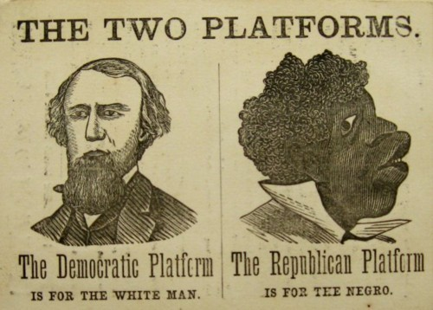

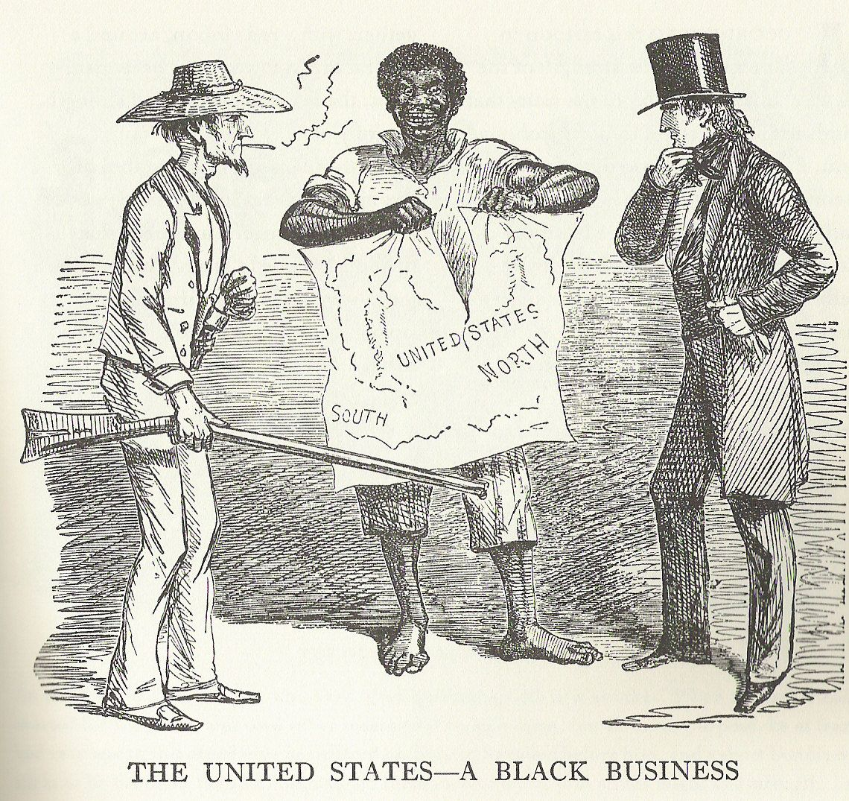
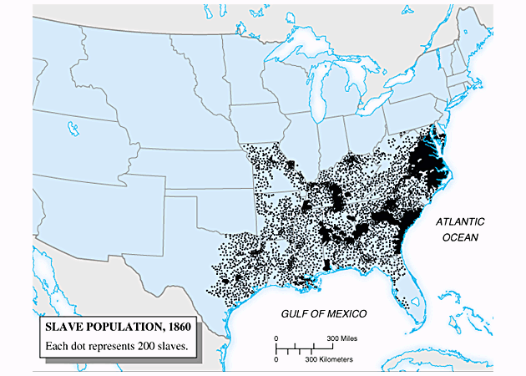

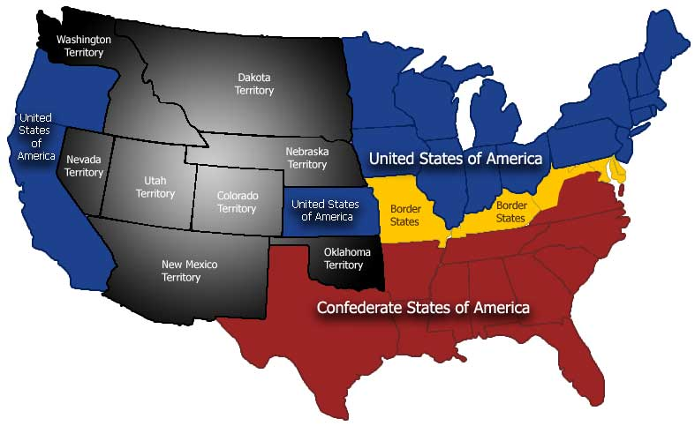

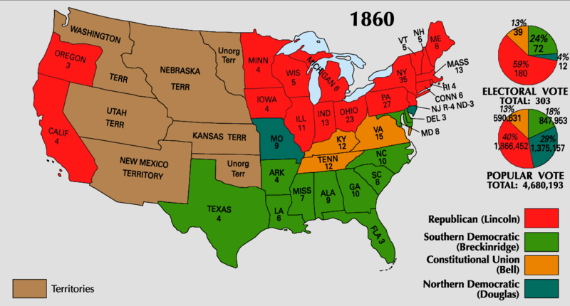

Declaration of Causes which Induced the Secession
of South Carolina (December 24, 1860)

On December 20, 1860, the South Carolina Convention voted unanimously for secession. Four days later, the Convention adopted two papers justifying secession. Parts of the “Declaration of Causes which Induced the Secession of South Carolina” follow:

The Constitution imposed certain duties upon the several states, and restrained the exercise of certain of their powers, which necessarily implied their continued existence as sovereign states.

A compact between the states established a government with defined objects and powers, limited to the exact words of the grant.

We affirm that these ends for which this government was instituted have been defeated. The government itself has destroyed them by the action of the non-slaveholding states. Those states have assumed the right of deciding upon the propriety of our domestic institutions [slavery]. They have denied the rights of property established in fifteen of the states and recognized by the Constitution. They have denounced as sinful the institution of slavery. They have permitted the open establishment among them of abolitionist societies, whose avowed object is to disturb the peace of and to take away the property of the citizens of other states. They have encouraged and assisted thousands of our slaves to leave their homes; and those who remain, have been incited by emissaries, books, and pictures, to servile insurrection.

For twenty-five years this agitation has been steadily increasing until it has now secured to its aid the power of the national government. A geographical line has been drawn across the Union, and all the states north of that line have united in the election of a man to the high office of President of the United States whose opinions and purposes are hostile to slavery. He is to be entrusted with the administration of the national government, because he has declared that that “government cannot endure permanently half slave, half free,” and that the public mind must rest in the belief that slavery is in the course of ultimate extinction.

On the 4th of March, he will take possession of the government. He has announced that the South shall be excluded from the common territory of the nation, . . . .and that a war must be waged against slavery until it shall cease throughout the United States.

We, therefore, the people of South Carolina, by our delegates in convention assembled, appealing to the Supreme Judge of the world for the rectitude of our intentions, have solemnly declared that the Union heretofore existing between this state and the other states of North America is dissolved. The state of South Carolina has resumed her position among the nations of the world, as separate and independent state, with full power to levy war, conclude peace, contract alliances, establish commerce, and to do all other acts and things which independent states may of right do.

Jefferson Davis’ First Inaugural Address
(February 18, 1861)

Jefferson Davis was elected as the first president of the Confederate States of America following secession. He gave this speech at his inauguration:

Gentlemen of the Congress of the Confederate States of America, Friends and Fellow-Citizens:- CALLED to the difficult and responsible station of Chief Executive of the provisional government which you have instituted, I approach the discharge of the duties assigned to me with a humble distrust of my abilities, but with a sustaining confidence in the wisdom of those who are to guide and aid me in the administration of public affairs, and an abiding faith in the virtue and patriotism of the people.

Looking forward to the speedy establishment of a permanent government to take the place of this, and which, by its greater moral and physical power, will be better able to combat with the many difficulties which arise from the conflicting interests of separate nations, I enter upon the duties of the office to which I have been chosen with the hope that the beginning of our career, as a Confederacy, may not be obstructed by hostile opposition to our enjoyment of the separate existence and independence which we have asserted, and, with the blessing of Providence, intend to maintain. Our present condition, achieved in a manner unprecedented in the history of nations, illustrates the American idea that governments rest upon the consent of the governed, and that it is the right of the people to alter or abolish governments whenever they become destructive of the ends for which they were established.

The declared purpose of the compact of union from which we have withdrawn was "to establish justice, insure domestic tranquility, provide for the common defense, promote the general welfare, and secure the blessings of liberty to ourselves and our posterity"; and when in the judgment of the sovereign States now composing this Confederacy it had been perverted from the purposes for which it was ordained, and had ceased to answer the ends for which it was established, a peaceful appeal to the ballot box declared that so far as they were concerned, the Government created by that compact should cease to exist. In this they merely asserted a right which the Declaration of Independence of 1776 had defined to be inalienable. Of the time and occasion for its exercise, they as sovereigns were the final judges, each for itself. The impartial and enlightened verdict of mankind will vindicate the rectitude of our conduct, and he, who knows the hearts of men, will judge of the sincerity with which we labored to preserve the government of our fathers in its spirit. The right solemnly proclaimed at the birth of the States and which has been affirmed and reaffirmed in the bills of rights of States subsequently admitted into the Union of 1789, undeniably recognizes in the people the power to resume the authority delegated for the purposes of government. Thus the sovereign States, here represented, proceeded to form this Confederacy, and it is by abuse of language that their act has been denominated a revolution. They formed a new alliance, but within each State its government has remained, and the rights of person and property have not been disturbed. The agent, through whom they communicated with foreign nations, is changed; but this does not necessarily interrupt their international relations.
Abraham Lincoln’s First Inaugural Address
(March 4, 1861)

Upon Abraham Lincoln’s election to the presidency, and after he had been sworn in, he gave this address:

Fellow-Citizens of the United States:
In compliance with a custom as old as the Government itself, I appear before you to address you briefly and to take in your presence the oath prescribed by the Constitution of the United States to be taken by the President before he enters on the execution of this office."

I do not consider it necessary at present for me to discuss those matters of administration about which there is no special anxiety or excitement.

Apprehension seems to exist among the people of the Southern States that by the accession of a Republican Administration their property and their peace and personal security are to be endangered. There has never been any reasonable cause for such apprehension. Indeed, the most ample evidence to the contrary has all the while existed and been open to their inspection. It is found in nearly all the published speeches of him who now addresses you. I do but quote from one of those speeches when I declare that—

I have no purpose, directly or indirectly, to interfere with the institution of slavery in the States where it exists. I believe I have no lawful right to do so, and I have no inclination to do so.

Those who nominated and elected me did so with full knowledge that I had made this and many similar declarations and had never recanted them; and more than this, they placed in the platform for my acceptance, and as a law to themselves and to me, the clear and emphatic resolution which I now read:

Resolved, That the maintenance inviolate of the rights of the States, and especially the right of each State to order and control its own domestic institutions according to its own judgment exclusively, is essential to that balance of power on which the perfection and endurance of our political fabric depend; and we denounce the lawless invasion by armed force of the soil of any State or Territory, no matter what pretext, as among the gravest of crimes.

I now reiterate these sentiments, and in doing so I only press upon the public attention the most conclusive evidence of which the case is susceptible that the property, peace, and security of no section are to be in any wise endangered by the now incoming Administration. I add, too, that all the protection which, consistently with the Constitution and the laws, can be given will be cheerfully given to all the States when lawfully demanded, for whatever cause--as cheerfully to one section as to another…

The Emancipation Proclamation
(January 1, 1863)

Abraham, President of the United States, declared this proclamation in the midst of the Civil War:

By the President of the United States of America: A Proclamation.

Whereas, on the twenty-second day of September, in the year of our Lord one thousand eight hundred and sixty-two, a proclamation was issued by the President of the United States, containing, among other things, the following, to wit:

"That on the first day of January, in the year of our Lord one thousand eight hundred and sixty-three, all persons held as slaves within any State or designated part of a State, the people whereof shall then be in rebellion against the United States, shall be then, thenceforward, and forever free; and the Executive Government of the United States, including the military and naval authority thereof, will recognize and maintain the freedom of such persons, and will do no act or acts to repress such persons, or any of them, in any efforts they may make for their actual freedom.

"That the Executive will, on the first day of January aforesaid, by proclamation, designate the States and parts of States, if any, in which the people thereof, respectively, shall then be in rebellion against the United States; and the fact that any State, or the people thereof, shall on that day be, in good faith, represented in the Congress of the United States by members chosen thereto at elections wherein a majority of the qualified voters of such State shall have participated, shall, in the absence of strong countervailing testimony, be deemed conclusive evidence that such State, and the people thereof, are not then in rebellion against the United States."

Now, therefore I, Abraham Lincoln, President of the United States, by virtue of the power in me vested as Commander-in-Chief, of the Army and Navy of the United States in time of actual armed rebellion against the authority and government of the United States, and as a fit and necessary war measure for suppressing said rebellion, do, on this first day of January, in the year of our Lord one thousand eight hundred and sixty-three, and in accordance with my purpose so to do publicly proclaimed for the full period of one hundred days, from the day first above mentioned, order and designate as the States and parts of States wherein the people thereof respectively, are this day in rebellion against the United States, the following, to wit:
Arkansas, Texas, Louisiana,…Mississippi, Alabama, Florida, Georgia, South Carolina, North Carolina, and Virginia, (except the forty-eight counties designated as West Virginia…), and which excepted parts, are for the present, left precisely as if this proclamation were not issued.
And by virtue of the power, and for the purpose aforesaid, I do order and declare that all persons held as slaves within said designated States, and parts of States, are, and henceforward shall be free; and that the Executive government of the United States, including the military and naval authorities thereof, will recognize and maintain the freedom of said persons.
And I hereby enjoin upon the people so declared to be free to abstain from all violence, unless in necessary self-defence; and I recommend to them that, in all cases when allowed, they labor faithfully for reasonable wages.

And I further declare and make known, that such persons of suitable condition, will be received into the armed service of the United States to garrison forts, positions, stations, and other places, and to man vessels of all sorts in said service.

And upon this act, sincerely believed to be an act of justice, warranted by the Constitution, upon military necessity, I invoke the considerate judgment of mankind, and the gracious favor of Almighty God.

In witness whereof, I have hereunto set my hand and caused the seal of the United States to be affixed.

Done at the City of Washington, this first day of January, in the year of our Lord one thousand eight hundred and sixty three, and of the Independence of the United States of America the eighty-seventh.

Northern Views

A ranking officer in the Union Army, Joshua Lawrence Chamberlain, had this to say about the Civil War:

All these thousands of men. Many of them not much more than boys. Each one of them some mother's son, some sister's brother, some daughter's father. Each one of them a whole person loved and cherished in some home far away. Many of them will never return. An army is power. Its entire purpose is to coerce others. This power can not be used carelessly or recklessly. This power can do great harm. We have seen more suffering than any man should ever see, and if there is going to be an end to it, it must be an end that justifies the cost. Now, somewhere out there is the Confederate army. They claim they are fighting for their independence, for their freedom. Now, I can not question their integrity. I believe they are wrong but I can not question it. But I do question a system that defends its own freedom while it denies it to an entire race of men. I will admit it, Tom. War is a scourge, but so is slavery. It is the systematic coercion of one group of men over another. It has been around since the book of Genesis. It exists in every corner of the world, but that is no excuse for us to tolerate it here when we find it right infront of our very eyes in our own country. As God as my witness, there is no one I hold in my heart dearer than you. But if your life, or mine, is part of the price to end this curse and free the Negro, then let God's work be done.
(Quoted in Killer Angels by Michael Shaara)

A Union soldier wrote this is a letter home:

July 14, 1861
Camp Clark, Washington
My very dear Sarah:
The indications are very strong that we shall move in a few days—perhaps tomorrow. Lest I should not be able to write again, I feel impelled to write a few lines that may fall under your eye when I shall be no more . . .
I have no misgivings about, or lack of confidence in the cause in which I am engaged, and my courage does not halt or falter. I know how strongly American Civilization now leans on the triumph of the Government and how great a debt we owe to those who went before us through the blood and sufferings of the Revolution. And I am willing—perfectly willing—to lay down all my joys in this life, to help maintain this Government, and to pay that debt . . .

Southern Views

Robert E. Lee, the leading Conferdate General, had this to say before the Civil War:

“There is a terrible war coming, and these young men who have never seen war cannot wait for it to happen, but I tell you, I wish that I owned every slave in the South, for I would free them all to avoid this war.”

The following is a letter fragment of an 1861 letter from Louisa Davis to Mrs. Alice Saunders. Both women are from the South. A typed version of the legible text is provided below:

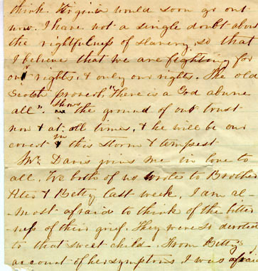

……think. Virginia could soon go out now. I have not a single doubt about the rightfulness of slavery, so that I believe that we are fighting for our rights, and only our rights. The old Scottish proverb, “There is a God above all.” Shows the -----of our trust ---- and at all times, and he will be our cover in this storm and tempest.

---- Davis joins me in love to all. We both of us wrote to ----- Alex and Betty last week. I am at most afraid to think of the ---- ---- of their grief. They ------ --------- to that sweet child. From Betty’s account of her symptoms I was afraid………
Bleeding Kansas

The following is an account of the violence following the Kansas-Nebraska Act which became known as “Bleeding Kansas.” Recall the details you studied earlier this week/last week:

Just under 400 emigrants left for Kansas in March of 1855. Months earlier, in November of 1854, the first territorial election to select a delegate to Congress took place. Of 2871 votes cast, the Congressional Committee created in 1856 to investigate the Kansas "troubles" determined that 1729 (60%) were illegal:

On March 30, 1855 there was another election, this one for a territorial legislature. There were, according the census just taken, 8,601 residents in Kansas, 2,905 of whom were eligible to vote. The Missourians returned in force. According to the Howard Committee, the special Congressional Committee,

The evening before, and the morning of the day of the election, about one thousand men arrived at Lawrence, and camped in a ravine a short distance from the town, and near the place of voting. They came, in wagons (of which there were over one hundred) or on horseback, under the command of Colonel Samuel Young, of Boone County, Missouri, and Claiborne F. Jackson, of Missouri. They were armed with guns, rifles, pistols and bowie knives; and had tents, music and flags with them. They brought with them two pieces of artillery, loaded with musket balls.

When the voting commenced, . . Colonel Young offered to vote. He refused to take the oath prescribed by the governor, but said he was a resident of the territory. He told Mr. Abbott, one of the judges, when asked if he intended to make Kansas his future home, that it was none of his business; if he were a resident then he should ask no more. After his vote was received, Colonel Young got upon the window sill and announced to the crowd that he had been permitted to vote, and they could all come up and vote. He told the judges that there was no use swearing the others, as they would all swear as he had. After the other judges had concluded to receive Colonel Young’s vote, Mr. Abbott resigned as judge of election, and Mr. Benjamin was elected in his place.

The polls were so much crowded till late in the evening that for a time they were obliged to get out by being hoisted up on the roof of the building, where the election was being held, and passing out over the house. Afterwards a passageway was made through the crowd by two lines of men being formed, through which voters could get to the polls. Colonel Young asked that the old men be allowed to go up first and vote, as they were tired with the traveling, and wanted to get back to camp. During the day the Missourians drove off the ground some of the citizens, Mr. Stearns, Mr. Bond and Mr. Willis. They threatened to shoot Mr. Bond, and made a rush after him, threatening him. As he ran from them, shots were fired at him as he jumped off the bank of the river and escaped

Webster-Hayne Debate

In 1830 a tremendous debate took place in Congress over a protective tariff that was supported by politicians in the North and opposed by politicians in the South. Daniel Webster from the North supported the tariff, and Robert Hayne from the South spoke out against it. Both debaters represented the positions of their sections of the country. The following is an excerpt from Robert Hayne’s remarks in the debate:

Webster tells us the tariff is not an "eastern measure"; neither do the west nor south claim it. If they care so little for the tariff, it is the more terrible that they will not revoke it in order to "bind the states more closely with the cords of affection ... [instead] the seeds of dissolution are already sown."

Webster has been making utterly unprovoked attacks on my state as "looking to disunion". I may have to reluctantly retaliate. SC has always shown "uniform, zealous, ardent, and uncalculating devotion to the union" ... We fought, with "noble daring, dreadful suffering, and heroic endurance" for the revolution. Then, in '98, the south (with the VA and KY resolutions) saved the liberty of the union again.

But what about the War of 1812, fought for "free trade and sailor's rights", for New England seamen? Though the south had nothing to gain from it; SC answered the call with "the noblest of her sons and half million in cash."

The Hartford Convention, composed of very prominent men of New England, and with the sanction of the Massachusetts legislature, met just when it was most doubtful whether the U.S. could survive the War. In strict secrecy they voted resolutions to weaken the government and avoid their own participation in the war. But just then the Battle of New Orleans saved the U.S. from ruin, and sent the Hartford delegates home in embarrassment.

The true friends of the Union are those who would limit the powers of the federal government strictly according to the constitution. Its enemies are those who are "constantly stealing power from the states" and adding power to the Federal Government; who would regulate all enterprises.

The "Carolina doctrine" as Webster calls it -- that a state may constitutionally act against a "gross, palpable, and deliberate violation of the constitution" -- which the SC legislature stated in Dec. 1828, is identical with the Virginia Resolutions of 1798 against the alien and sedition laws.

Several New England states disputed the resolution, but it was vindicated by Mr. Madison's report of '99 [in congress]. This stated that "in the case of a deliberate, palpable, and dangerous exercise [of unconstitutional powers] the states ... [have the duty to arrest] the progress of the evil..."
Mr. Madison said, the constitution being a compact or agreement among equal parties -- the states -- with no higher authority to decide a dispute, "must themselves decide in the last resort, questions ... of sufficient magnitude." Without such right of interposition by the states, "there would be an end to all relief from usurped power."

In 11/98 and 11/99, Kentucky passed similar resolutions, stating "that a nullification by [the states] of all unauthorized acts done under the color of [the constitution] is the rightful remedy."

In 1821, Jefferson called it "a fatal heresy to suppose that" either the state governments or the Fed. government is superior to the other, and in 1825, a protest he wrote for the Virginia legislature against Federal tariff and internal improvement measures, said "These acts of the federal government [are] null and void ... Virginia would consider a dissolution of the union as among the greatest [possible] calamities ... yet ... there is one greater -- submission to a government of unlimited powers.

In a letter to Mr. Giles, Jefferson said "the federal ... government is advancing toward the usurpation of all [state powers] ... Under the power to regulate commerce, they assume [power] over agriculture and manufacturing ... under the authority to establish post roads, they claim that of cutting down mountains ... and digging canals." What to do? "When the sole alternatives left are a dissolution of our union ... or submission to a government of unlimited powers [we must chose dissolution]."

